Inclusion, amenities featured in new Prospect MAX bus line
Posted: 6:38 AM, Nov 15, 2019

Updated: 6:38 AM, Nov 15, 2019
By: Charlie Keegan

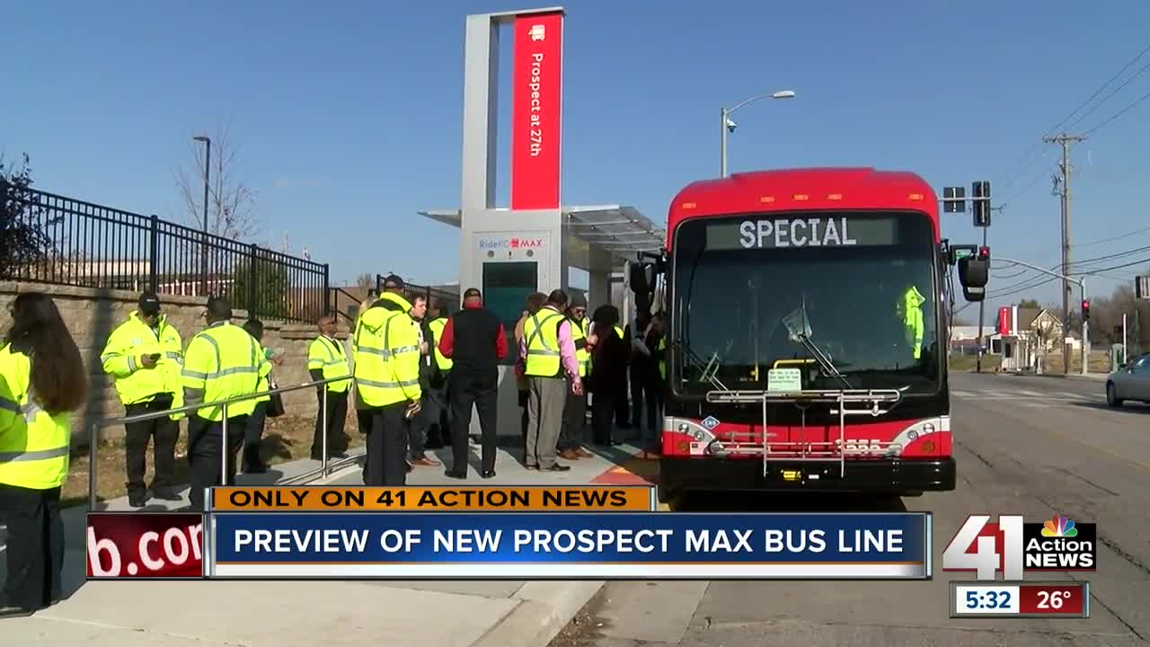
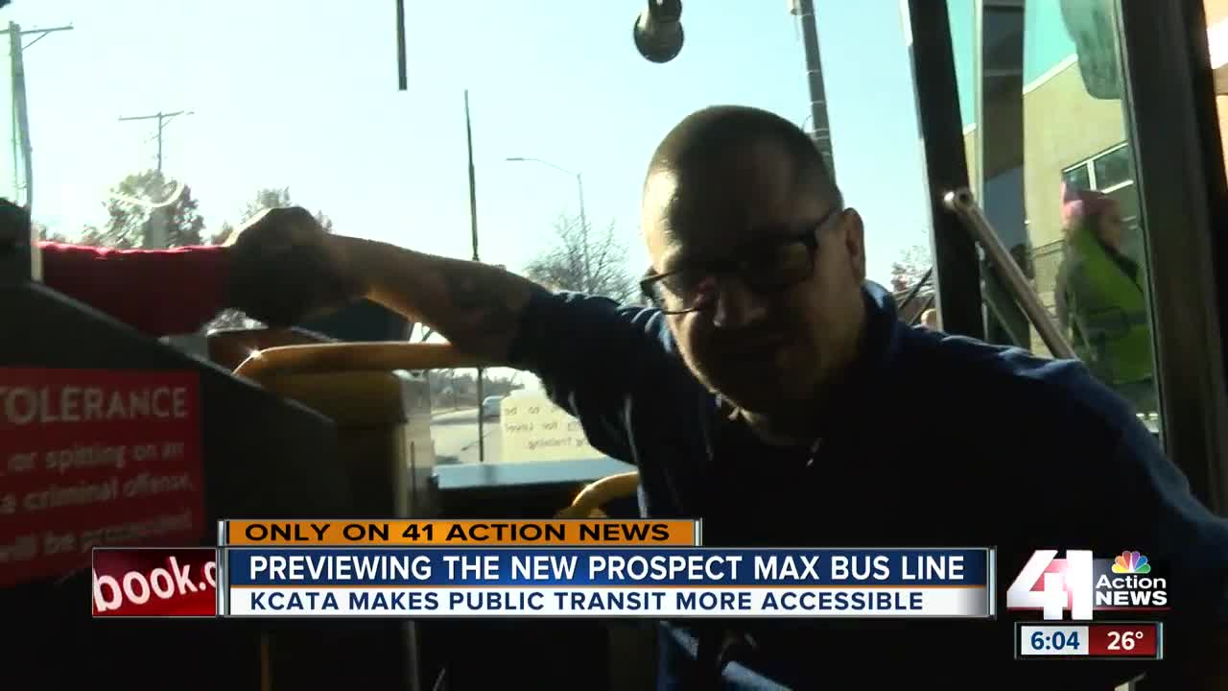
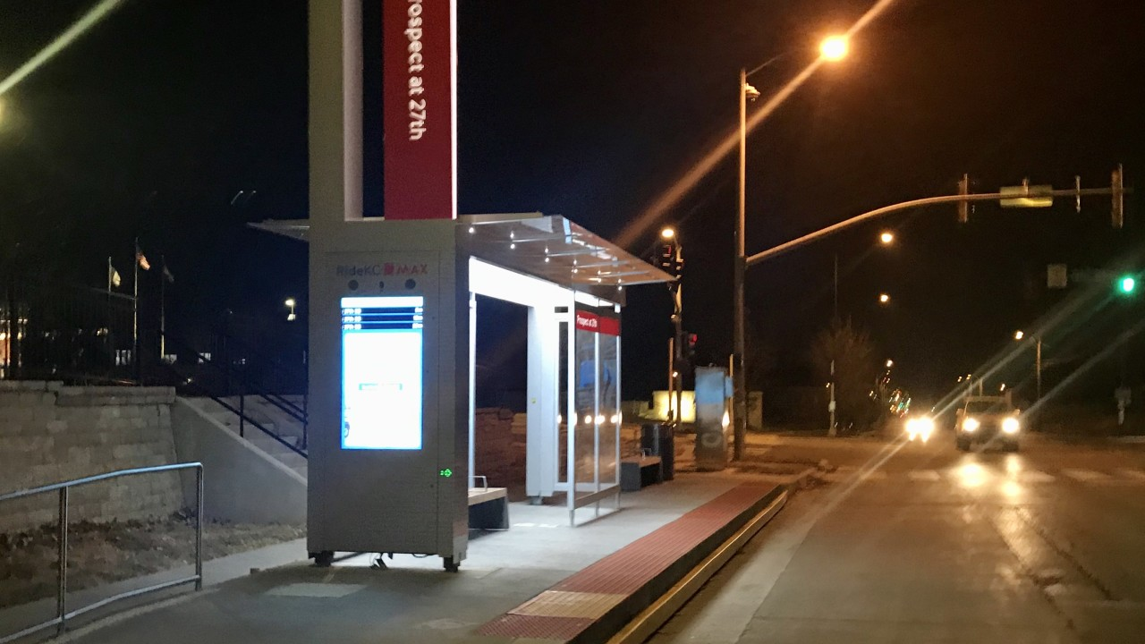
KANSAS CITY, Mo. — When service begins on the new Prospect MAXbus rapid transit system in Kansas City, Missouri, on Dec. 9, riders will notice a amenities and special considerations not currently on any other bus line in the Kansas City Area Transportation Authority’s system.
One design is so unique the agency is filing a patent.
Features include USB charging ports on board the bus, free WiFi at bus platforms, raised bus platforms to allow for level boarding, heated concrete to melt snow and ice on the platforms and an improved signal prioritization program which allows buses to extend green lights or shorten red lights to get passengers to their destinations even faster.
“Prospect MAX has every amenity we could throw at it to make the customer experience better,” said David Johnson, the KCATA’s chief strategy officer and a project manager for the Prospect MAX bus rapid transit project.
Thursday, the agency gave 41 Action News a preview of the $56 million project.
The Prospect MAX line will connect riders between two brand new transit centers at East 75th Street and Prospect Avenue and East 12th Street and Charlotte Street.
Similar to the Main Street and Troost Avenue MAX routes, the Prospect MAX bus line makes fewer stops than a normal route, with the goal of getting riders to their destinations in a shorter amount of time.
Before rolling out the new bus line, KCATA wanted to make it as inclusive as possible for people with disabilities.
“We’re trying to be the most accessible transit system in the country,” Johnson pointed out.
Representatives from The Whole Person, an organization that advocates on behalf of people with disabilities, worked with the KCATA to design features to help people who use wheelchairs or are visually impaired.
The new platforms are the same height as the bus, which means there’s no need for a ramp to get a wheelchair on board, and it eliminates a step, which could be problematic for people who are blind.
“I’m glad our transportation here in Kansas City is actually trying to be inclusive, be aware of our needs and it's exciting for me because that's exactly what we do at The Whole Person; we try to advocate for the individual with a disability, provide them with the resources that they need to live as independently as they can,” Rick Haith, who has used a wheelchair for the past 19 years, said.
One obstacle the raised platforms created was buses scraping up against the side, damaging and scratching the new buses.
So, the KCATA designed a roller to place on the front corner of the bus. It acts as a bumper, notifying the bus driver they are a certain distance from the platform.
“We determined it was preventing all damage. We have not had any vehicle damage since the rollers were put on,” Johnson said proudly.
Now, the KCATA has filed a patent on the roller. It plans to add the piece of equipment to buses from other routes, which will also use the MAX platforms.
The KCATA is paying for this project with a combination of local GO bond dollars and federal grant money. As part of the project, Johnson said the KCATA built about five miles of sidewalks along the route.
Copyright 2019 Scripps Media, Inc. All rights reserved. This material may not be published, broadcast, rewritten, or redistributed.

